A000-Afr-Nigeria-Benin-Edo Peoples- Shaman-18th c

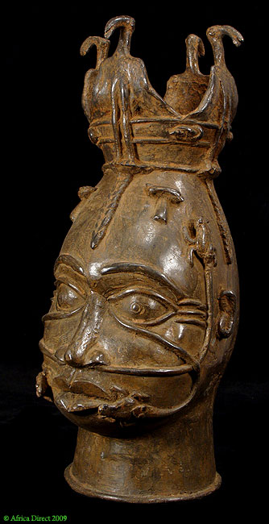

Afr-Nigeria-Benin-Edo Peoples- Shaman-18th c

Case No.: 6

**Accession No.**

**Formal Label:** Afr-Nigeria-Benin-Edo Peoples- Shaman-18th c

**Display Description:**

This18th c head of a shaman shows magical and symbolic motifs over its surface.  Serpents are shown emerging from the eyes and nostrils shown devouring frogs.  Two miniature stone tools are shown on the forehead with locks or strands of hair on the forehead and sides of the head. Four birds stand as part of a crown like headdress most likely representing vultures that are prominent in Benin mythology and religion.  The head is a mixture of magical and symbolic motifs  nown in other examples of Benin art.  The modern caster was true to his early model inasmuch as he has set small bits 0f iron into the eyes representing the pupils and retaining the overall sensibility of the original.

**LC Classification:**

**Date or Time Horizon:**

**Geographical Area:**

**Map:**

**GPS coordinates:**

**Cultural Affiliation:**

**Media:**

**Dimensions: H** 17.5 inch

**Weight:**

**Condition:**

**Provenance:**

**Discussion:**

**References:**

Augustus Pitt-Rivers. 1900. *Antique works of art from Benin: collected by Lieutenant-General Pitt Rivers.* Publisher: London : Privately printed, 1900.

Hagen, K. 1900. Altertumer von Benin, *Jahrbuch der hamburgischen Wissenschaftlichen Anstalten*, V. XVII.

Ling Roth, H. [1968 [1903] *Great Benin, its customs, art and horrors*. London: Routledge & Kegan Paul Ltd.

Dark, P. J. C., W. & B. Foreman. 1960. Benin art. London: Paul Hamlyn..

Dark, P. J.C. 1973. *An Introduction to Benin Art and Technology*. Oxford: At the Clarendon Press.

Ben-Amos, Paula. 1980. *The art of Benin.* New York, N.Y.: Thames and Hudson.

Freyer, Bryna. 1987. *Royal Benin art*. Washington, D.C.: Published for the National Museum of African Art by the Smithsonian Institution Press.

Ezra, Kate. 1992. *Royal art of Benin*, *The Perls collection in the Metropolitan Museum of Art*. New York: Metropolitan Museum of Art : Distributed by H. N. Abrams..

Duchâteau, Armand. 1994. *Benin, Royal art of Africa from the Museum für Völkerkunde, Vienna*. [Houston]: Museum of Fine Arts, Houston ; Munich: Prestel.